**Practical-9**

**Aim: Program Related to** **ARITHMETIC Instruction.**

1. Load 41H in Accumulator and 03H in Register C. Add these two   numbers and store result at the memory location 1100H.

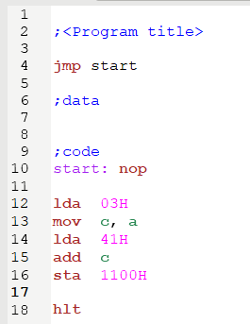

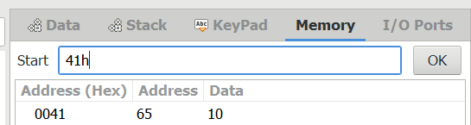

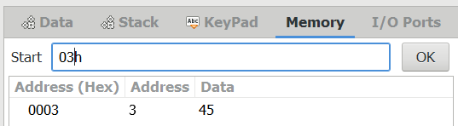

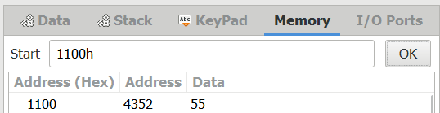

1. Store two numbers in memory locations C200H and C201H. Add these two numbers and store result on memory location C202H(numbers are 59H and 77H).

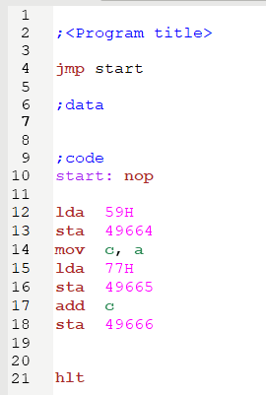

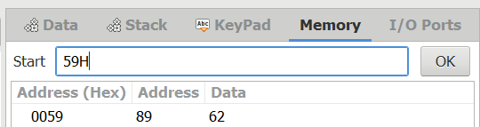

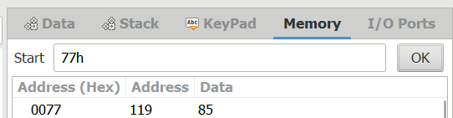

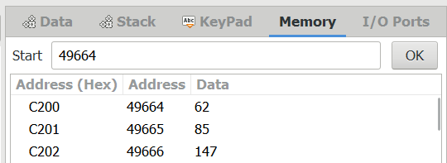

1. Load the accumulator by 40H and get another number from memory location 1102H 03H) and add the two numbers. Store the result to location 1105H check the carry flag.

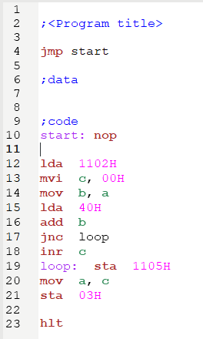 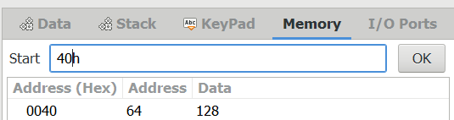

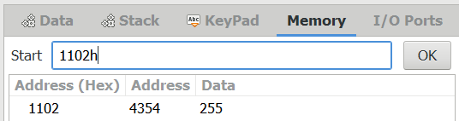

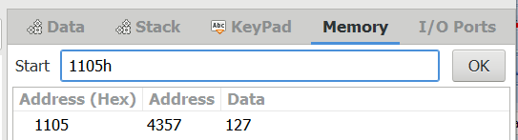

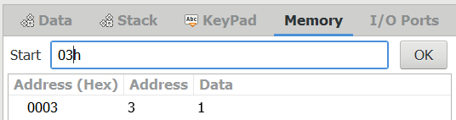

1. Load a numbers 49H in register B and number 12H in register A. perform subtraction and store result to memory location C200H.

